Assessment: Lab 3

Student Name: Zahi Masarwa

Lab Professor Name: *Mel Sanschagrin*

Lab Section Number: *303*

Due Date: 02/05/2021

# **General program steps**

The program will input a name and will calculate the length of each character in the string and print it

Convert all charterers to upper cases and at the print programmer name.

# **Pseudocode**

Start

Declare new Scanner;

Output “please Enter you full name”

Declare string name

Input name as string

Output “The length of your name is:"+length of name characters”

Output “The Name to Uppercase:” +name converted to upper case

Output "Programed By: Zahi Masarwa"

End

# **Flowchart**

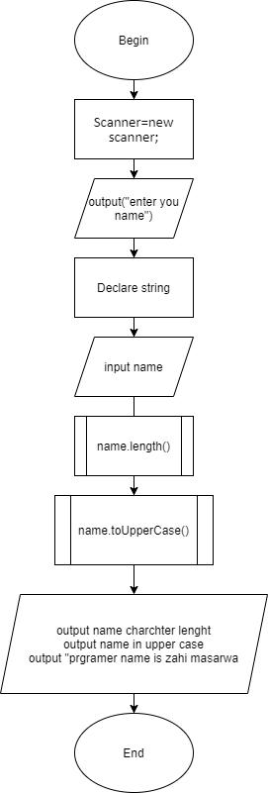

# **Test Plan for Algorithm**

|  |  |  |  |
| --- | --- | --- | --- |
| input | Expected outputs | Actual outputs (Algorithm) | Description |
| Zahi Masarwa | 13  ZAHI MASARWA  Programmer name is zahi masarwa | 13  ZAHI MASARWA  Programmer name is zahi masarwa | The code takes the name zahi masarwa and output  Length is 13  The name in all capital  And out put a text programmer name is zahi masarwa |

# **Test Plan for java program**

|  |  |  |  |
| --- | --- | --- | --- |
| input | Expected outputs | Actual outputs (Algorithm) | Description |
| Zahi Masarwa | please Enter you full name  The length of your name is:12  The Name to Uppercase: ZAHI MASARWA  Programed By:zahi masarwa | please Enter you full name  The length of your name is:12  The Name To Uppercase:ZAHI MASARWA  Programed By:zahi masarwa | The code takes the name Zahi Masarwa and output  Length is 13  The name in all capital  And out put a text programmer name is zahi masarwa |

# **Screen shot of program execution**

